
YCCHAL Participation Handbook
Constitution and By-Laws

YCCHAL PARTICIPATION
The YCCHAL was founded in 1991 as a resource for homeschool students in Yellowstone County to provide varsity level high school team sports. Over the years, YCCHAL has expanded to offer elementary and junior high team sports. The goal of this league is to provide a Christian approach to athletics by demonstrating and encouraging Christ-like character both on and off the field of competition while promoting sportsmanship, fellowship, physical fitness, and healthy competition.
Statement of Faith:
We believe in and unqualifiedly affirm: 1) The inspiration of the Bible, equally in all parts and without error in its origin; 2) The One God, eternal existent Father, Son and Holy Spirit, who created man by direct immediate act; 3) The fall of man, the need of regeneration by the operation of the Holy Spirit on the basis of grace through faith and the resurrection of all to life or damnation; 4) The pre-existence, incarnation, virgin birth, sinless life, miracles, substitutional death, bodily resurrection, ascension to heaven, and second coming of the Lord Jesus Christ; and 5) The spiritual relationship of all believers by the Lord Jesus Christ, Living a life of righteous works, separated from the world, witnessing of His saving grace through the ministry of the Holy Spirit. YCCHAL, in observance of these articles of faith, will encourage open prayer at practice and games. Scripture memory and other scriptural character building practices will be encouraged in all aspects of our program.
Rules of Conduct and Participation:
- Athletes must be actively participating in an ongoing home education program under the direction of their parent or guardian and must not be enrolled as a full time student within any public schools. Any exceptions to this policy will be outlined in the Constitution and By-laws. Athletes are required to show respect and submit to the authority of their coaches at practices and games.

- Athletes are expected to show respect to teammates and only give them positive encouragement. Ridiculing, taunting, demeaning, or reproving of team members will not be acceptable.
- Athletes are expected to accept their coach’s tactical decisions, such as player positioning and playing time.
- Inappropriate actions and/or attitudes by an athlete toward teammates or coaches, may result in his/her suspension, or may result in an athlete being benched during a game. Athletes must agree to follow the instructions and directions of coaches, the athletic director and the executive council, understanding that they have the best interest of the players, coaches and league in mind.
- Officials are in a position of authority and shall be shown respect.
- Athletes should respect opponents, and play in such a manner that does not purposely attempt to hurt or injure another player.
- Athletes should display good sportsmanship, helping a player back to their feet and shaking the hands of opponents when given the opportunity.
- Athletes agree to train and play to the best of their ability.
- Athletes should maintain a positive attitude.
- Athletes are responsible for knowing about team activities, practices and games.
- Athletes should arrive on time and be prepared for all practices, games, tournaments, and activities during the season.
- The amount of time an athlete plays is at the discretion of the coach.
- Athletes should notify coaches of any absences prior to practices or games.
- Athletes should use encouraging language and refrain from foul, abusive or offensive language.
- YCCHAL practices a no-tolerance policy regarding alcohol and illegal drug use among student athletes. Student athletes found to be using any such controlled substance will be subject to eviction from their team.
- Athletes will not allow their enthusiasm for their sport to override their responsibilities to their family, education or church.
- No Jewelry of any kind may be worn by any athlete due to the safety issues involved. Glasses are to be worn securely.
- Dress during games and tournaments should reflect well on the League & not have inappropriate advertising or slogans.
- Athletes are asked to wear only non-scuff shoes on the gym floors.

Attitudes of Players:
Our attitudes take precedence over every other aspect concerning the sport. As followers of Christ, we bear His Name and so everything we say and do should reflect Him. If a player is displaying a disrespectful attitude toward a coach, he/she will be benched. Disrespect must be stopped immediately. If the player continues to be disrespectful, involvement of the athletic director or the Board may be necessary. Playing time should be determined on ability, team unity and attitude. We will not allow a player with a negative, angry, disrespectful, or self-centered attitude to continue to play. Players are expected to rise to the standard. The standard is not lowered for the player. The Word of God is the standard.
Parental Code of Conduct:
- I will treat my child’s coaches with respect at all times, recognizing that they are volunteers and not professional coaches. I will do my best to support and encourage them in their endeavors.
- I will not speak disparagingly or disrespectfully about my child’s coaches, teammates, or other parents in the League, either in front of my child or to other parents or players.
- I agree to support the coach and the team. I agree to accept the coach’s decisions regarding my child’s playing time and position and agree to not interfere, at any time, with the duties and responsibilities of the coach(es). If I have a concern regarding my child’s playing time, I agree to follow the appropriate steps to communicate and resolve any differences of opinion by following the steps laid out in the conflict resolution agreement.
- I will support my child’s coach in maintaining discipline and good behavior on the team. I will also assure that my child fulfills all the requirements for attendance, care of equipment, Bible verse assignment, and other work assignment by the coach.
- I will remember that this league has both an educational and competitive purpose; therefore, my child is not guaranteed equal playing time during competitions.
- I will endeavor to keep my language and conduct above reproach whenever I attend practices or games so as to reflect well on the YCCHAL and on the Lord we serve, remembering that we all have the same goal in mind, and all need to be quick to extend Grace.
- I will show respect for game officials and will refrain from shouting, rebuking, or arguing with their judgments. Likewise, I will treat opposing players and spectators with respect and courtesy at all times. (Remembering that as we play other teams in the MCAA we are all a part of the same Body, and as we play other teams in the county we are called to be a light.)
- I understand that there are consequences for unsportsmanlike conduct towards officials, coaches, opponents, and players that may result in the removal of myself from my child’s game and future games or league activities.
- I agree to encourage, support, and affirm my child’s play on the field.
- I understand that this league is organized and run by the volunteer hours of all involved, and agree to fulfill my responsibility as a parent by completing all assigned game day duties and helping out with my child’s team.
- I understand that it is my responsibility to know about team practices, activities and games. It is also my responsibility to know how to access the schedule and keep myself informed of the schedule and changes to the schedule.
- I understand that unless my child is ill or injured, he/she is expected to attend all practices, games and activities pertaining to his/her team.
- I agree to help my athlete meet team expectations and commitments to the best of my ability.
- I agree to comply with the rules, policies and procedures of the team, administrators and board members of the
YCCHAL.
Communication:
Communication is vital between coaches, players, parents, the athletic director, and the board of directors. Please assume the best in all circumstances and remember to extend Grace, as Grace has been freely given to us. If a parent, athlete, or coach has an issue with playing time, playing position, or any other aspect of the game/team, it is expected that he/she will follow the steps to resolve the issue as outlined by the conflict resolution agreement.
Conflict Resolution:
If your brother sins against you go and show him his fault, just between the two of you. If he listens to you, you have won your brother over. But if he will not listen, take one or two others along, so that every matter may be established by the testimony of two or three witnesses.
Matthew 18: 15-16
As a parent, guardian, or athlete involved with the YCCHAL, I will agree to the following Biblical steps in resolving any problem, conflict, or disagreement with a coach, parent, player, or other participant in the YCCHAL.
- I will pray that everything I say honors God. I will not use personal attacks, foul language, shouting, physical force, gossip, or other intimidating behavior at any time.
- Before going to the coach, I will take some time to check my own motives, intentions, and behavior, taking responsibility for any wrong I might have done and asking God to take the log out of my eye before trying to take the speck out of my brother’s eye. ~ Matthew 7:4
- I will contact the coach in person or by telephone, at an appropriate time to discuss the matter directly. I will not contact him/her through text messages or email. I will not use email to register a complaint.
- I will not attempt to discuss a problem or a complaint with a coach immediately before, during, or after a game. I will not disrupt a practice in order to discuss a complaint, but will address the matter at a neutral time.
- If the problem is not resolved, I will tell the coach that a third party needs to be involved, and then contact the athletic director, or a member of the Executive Council to arrange a meeting with the coach present.
- If these steps have not resolved the problem, and I wish to seek formal resolution from the Executive Council, I will submit a signed, written complaint to the Executive Council.
- Both parents and all athletes must agree to this conflict resolution in order to participate in YCCHAL.
Bullying:
- Bullying by a parent, player, coach, board member, or athletic director is never acceptable.
- Bullying is the use of aggression with the intention of hurting another person.
- Bullying results in pain and distress to the victim. It is done to intimidate, coerce, control, embarrass, exclude or instill fear.
- Bullying can be emotional~ being unfriendly, excluding (emotionally and physically), sending hurtful text messages, or tormenting (picking on, threatening gestures or comments).
- Bullying can be physical~ pushing, kicking, hitting, punching or any use of violence.
- Bullying can be racial~ racial taunts, jokes or gestures
- Bullying can be sexual~ unwanted physical contact or sexual comments
- Bullying can be verbal~ name calling, sarcasm, spreading rumors or picking on
- Bullying is never ok and will not be tolerated.
- Anyone believing to be the victim of bullying should follow the procedures outlined in the conflict resolution section.
- Anyone participating in bullying will be asked to change his/her behavior.

If bullying continues, dismissal from YCCHAL may be necessary.

Player Eligibility:
Student athletes are allowed to participate in the YCCHAL at the High School level for four (4) years.
- An extension of a fifth (5th) year of participation will be granted to those students who are in the eighth (8th) grade and participate at the JV or Varsity level. The Executive Council of the YCCHAL and the Board of Directors of the MCAA must be informed in writing of such participation.
- Seventh (7th) grade student athletes are allowed to participate in the YCCHAL at the High School level only when the total athlete participation is below the following:
Soccer—12; Volleyball—9; Basketball—10, without losing a year of eligibility. The Executive Council of the YCCHAL and the Board of Directors of the MCAA must be informed in writing of such participation.
- In this case, seventh (7th) grade student athletes are allowed to participate in the YCCHAL at a Sub-Varsity High School level without losing a year of eligibility. The Executive Council of he YCCHAL and the Board of Directors of the MCAA must be informed in writing of such participation.
- Teams will not consist of co-ed rosters. Girls will participate with all girls’ teams and boys will participate with all boys’ teams.
- Existing MCAA member schools without enough students to participate in the current sport may combine with another church school/association, but only with MCAA Board approval.
- Athletes must be actively participating in a home education program under the direction of their parent or guardian.
- No athlete is eligible to participate who has received a GED.
- No athlete is eligible to participate who has gone through a graduation ceremony.
Grades: No player may play with grades that are not “passing”. Parents are required to monitor this and self discipline their children.
If there is an excessive number of players signed up to play a sport, the Coach will determine the maximum number needed. Tryouts, or other skill level assessment, will be used to determine team members.
Lettering:
Please see Article IV of the by-laws.
In addition to Article IV, a player must be a varsity player. Must be in high school as junior high players are ineligible. Should have memorized the team verse or scripture verses given by the coach. Must have demonstrated respectful attitude to coach and teammates. Needs to have played in at least four conference games prior to the tournament.

Music:
All music played at YCCHAL games and/or practices is subject to board review and approval. While the preference is for Christian music to be played, secular music is allowed, provided that it does not have inappropriate language or subject matter. Below are general guidelines that should be used in the selection of music:
- Acceptable: Songs played on a Christian radio station (Air1, The Effect, K-Love, etc); Instrumental music; Secular songs with a positive message
- Unacceptable: Lyrics that contain cursing (even if it is "bleeped" out); Lyrics with derogatory or slang words for any race, gender, etc. or that objectify men or women; Lyrics which discuss gambling, violence, drug or alcohol abuse, etc.
Coaching Staff:
Recruitment: Coaches and assistant coaches may be recruited by the Board, referred by parents, parents of an athlete, or other interested parties as approved by the Board. Head coaches will be allowed to determine their assistants with Board approval.
The coaching staff for each sport for each season will be reviewed and approved by the Board as stated in the Bylaws. The Board may require statements of faith, resumes, letters of recommendation or other ways to ensure the prospective coaches will train the athletes under Christ centered coaching. Complaints and charges will be handled as outlined in the Bylaws.
Since this is a competitive league and future games with surrounding schools may be dependent on our ability to field quality teams, the Council’s decision will be based on the training and experience of the coaches with an emphasis on Christian character. A stipend of one athlete fee per head coach or head coach position (not to exceed 19 total positions) will be offered.

Coaching responsibilities, expectations and obligations:
In accordance with the bylaws, coaches are to require the athletes to memorize scripture, have devotions, pray together, as well as emphasize Christian character.
Coaches are to demonstrate Christian character in their actions both on and off the field of competition. It is the goal of YCCHAL teams to be the best example for Christ of any team we play on and off the court or field. Coaches are asked to develop and invest in all players. Players that feel valued will work harder and develop faster.
Coaches’ and athletes' dress is to be modest, nice and in accordance with the bylaws. Coaches need to communicate dress expectations to their team for games & tournaments, whether that be uniforms, warm-ups, or dress attire.
Attitudes of Coaches:
Coaches have a wonderful opportunity and a privilege! They are in a position that teaches, mentors, models, and has authority. These athletes have been placed in their care to be taught the skill of the sport, to be taught team building and team unity, and to be taught what it looks like to follow Christ in all circumstances. A coach's attitude should say, “I believe in you” to each member of the team. Coaches should not use words that degrade the players. Athletes look up to their coach for guidance, support, encouragement, and Truth, therefore the attitude of the coach should reflect his/her trust in the Lord. We pray our coaches remember the God of all Grace is faithful to give wisdom, creativity, patience and perseverance as he/she serves these young athletes of the YCCHAL. We thank you, coaches, so very much for the giving of your talents, experience, wisdom, time and especially of yourselves. For more on the responsibilities of the coaches, please refer to Article VI in the YCCHAL Constitution and Article 11 of the YCCHAL By-laws.
Assistant Coaches:
Each head coach is required to have at least one assistant coach. All YCCHAL coaches give a tremendous amount of time, energy, talent, and sleepless nights for the benefit of their team. The Board would like to “lighten the load” of each coach by each having an assistant. The assistant coach is to respect, support, encourage, and when needed, possibly admonish the head coach. He/she may do this in a number of ways: by being an extra set of eyes and ears, by giving input at practices and games, by being a sounding board, by being an encourager, by protecting, and by offering accountability.
The head coach should seek and value the opinions of the assistant coach.
Coaches Evaluations:
Coaches serve because they love the game & want to speak into our League athletes. Parents are asked to encourage & give positive feedback to our coaches & to live out the Parental Code of Conduct mentioned before, as well as a Coaches' Evaluation at the end of the season. These forms can be found online at ycchal.org under documents.Forms can be filled out online and returned electronically. They are then given to the AD and the President and the feedback is shared with the Board and then the coaches.

Tournaments and Away Games:
It is the intention of the League to encourage team participation in tournaments.
The Rules for dress is: to reflect well on the League, team uniform/warm-ups, and Christian conduct apply for the entire team for the duration of the trip, not just during games. The following will also be enforced:
- No members of the opposite sex in team member’s rooms.
- Curfew will be enforced.
- All players are required to attend all practices, devotions, meetings, etc, during the tournament.
- A chaperone will be assigned to each room, preferably a team member’s parent.
- Swimwear is to be modest, covering midriff, cleavage and buttocks.
- Any objectionable behavior may be cause for the team member's parents to be called, requiring them to be removed from the tournament and the player will no longer be eligible for playing on any YCCHAL team. Eligibility for future sports will require application and approval by the Board.
Equipment and uniforms:
Equipment and uniforms are the property of the League. Players are responsible for returning their clean uniforms at the end of the season. Lost or unreasonable damage to a uniform will be cause for the charge of a uniform replacement fee. Each teams’ coach is responsible for checking out the equipment from the equipment committee at the start of the season and taking reasonable care of the equipment during the season. Requests for additional equipment need to be addressed to the athletic director.
Traveling Teams/Outside Tournaments:
Outside experience and tournaments are encouraged for all players. Use of League equipment or uniforms will be considered on a case by case basis. General considerations are that the majority of the players are active in YCCHAL, the games or tournaments do not interfere with the YCCHAL scheduled games, practices or season, and the team agrees to present Christian character. Uniforms and equipment may be recalled at any time should the League decide that the team or its coach is not within the guidelines required.
The Philosophies of Play with the YCCHAL are:
Play Time:
In the 5th/6th grade, play time should be equitable between all players: This level is for developmental purposes. With a competitive coach, this may be difficult to enforce, yet please try to give game time to all players. In the home school league, we do not know which athletes will stay with us, so please develop all players.
In the 7th/8th grade, the level of competition increases as does the level of play. However, all athletes need game time to be developed. So, please think beyond this year’s season as you develop players. Again, we need to be developing those players that will stay with the Knights.
In the Junior Varsity program, the level of competition increases dramatically. Playing time is still important to each player to prepare them for the varsity level.
In the Varsity program, the goal is to win games, earn a good seed for tournament, and ultimately, win the MCAA State Tournament, while still conducting ourselves in Christ’s likeness and with good sportsmanship. Coaches are to make a conscious effort to play all team members for a portion of each match of competition. The athlete is encouraged to make every effort to improve their game throughout the year. If the athlete feels their playing time needs to be adjusted, it is the player's responsibility to individually approach the coach and ask what they can do to increase their playing time while remembering to be coachable. These are life lessons athletics instills in the individual, and the parents should allow room for their child to grow in this communication.

Parents Involvement:
Parent’s involvement is necessary in order to successfully run this league. All parents are required to help with parental team responsibilities during their season such as keeping the book, score clock, concessions, taking stats, clean-up, and set-up. Parental involvement with the team during practice, games, and team-building activities will be at the coach’s discretion. All outside activities for a team should be approved and coordinated with the coach.

Committees:
All families are encouraged to contribute to the running of the YCCHAL by serving in some capacity outside of parental team responsibilities. The idea behind committees is to allow everyone to be a part of the daily functioning of the athletic league, as well as prevent burn out from any single family that is carrying too much of the load. The committee service is separate from the parental duties performed during games. Our desire is not to burden anyone, but to include everyone. Our goal is to allow and encourage each family to contribute to the league in a way that would “fit” their gifting, and be a blessing to the one serving as well as the ones being served.
Uniform Responsibility:
- Laundering Instructions: Wash uniform in cold water only, treat stains as needed.
Wash like colors together and hang to air dry.
- Return your athlete’s full uniform(s) freshly cleaned, in a zip-lock bag.
- If the uniform, or parts of the uniform, have to be replaced due to damage or loss, you will be charged for replacement costs.
Fees:
Fees may vary from year to year depending on the expenses of the YCCHAL. Fees are used to pay for officials, equipment and facilities, and high school coaches. Our desire is to keep fees down so that all that would like to participate can do so. In order to do this, it is vital that we have the entire league involved in fundraising activities. Fees for the 2025/2026 season are as follows: High School $400, Jr. High and Elementary $200.
Fundraising: YCCHAL is a 501c(3) Tax Deductible Charity
Forms can be found at www.ycchal.org under Documents then Fundraising.
YCCHAL is greatly blessed by our corporate & family donors. Please thank & patronize our sponsors.
Team: In an effort to encourage a league vision & volunteerism, each athlete is encouraged to participate in team fundraising. These events are planned within individual teams at the present time. Funds from team fundraisers are typically used by teams to help cover expenses for the team. At times they are used to purchase special team apparel and equipment. Sometimes they are also used to provide athlete scholarships for play.
Individual: Different opportunities are available each season to help athletes pay for their fees or traveling costs associated with participating in YCCHAL athletics.
End of Year League Meeting:
Because we are a parent-led league, each family needs to make every effort to participate in the board elections and recap of the year in April or May. Board responsibilities can be found on ycchal.org and are for a 1 year term. All parents are encouraged to pray about how God would use them to grow and serve this league. Any member of the YCCHAL is welcome to run for a board position at the year end meeting.

Yellowstone County Christian Home School Athletic League
Constitution (updated 4/29/2025)

Article I: Name
The name of this organization is the Yellowstone County Christian Home School Athletic League.
(YCCHAL)

Article II: Purposes
- To provide a Christian athletic opportunity which instills and demonstrates Christ-like character both on and off the field of competition.
- To promote fellowship, sportsmanship and healthy competition with other young people.

Article III: Statement of Faith
- We believe in and unqualifiedly affirm:
  - The inspiration of the Bible, equally in all parts and without error in its origin.
  - The one God, eternally existent Father, Son, and Holy Spirit, who created man by a direct immediate act.
  - The pre-existence, incarnation, virgin birth, sinless life, miracles, substitutionary death, bodily resurrection, ascension to Heaven, and Second Coming of the Lord Jesus Christ.
  - The fall of man, the need of regeneration by the operation of the Holy Spirit on the basis of Grace through faith and the resurrection of all: to life or damnation.
  - The spiritual relationship of all believers by the Lord Jesus Christ, living a life of righteous works, separated from the world, witnessing of His saving grace through the ministry of the Holy Spirit.
- YCCHAL in observance of these articles of faith will encourage open prayer at practice and games. Scripture memory and other scriptural character building practices will be used as part of our program.

Article IV: The Membership
- All home school families wishing to have their children compete for the YCCHAL must sign the statement of faith, release of liability, and rules of conduct form to become a member.
- All meetings will be open to parents and athletes, however, only member parents may vote.
Article V: Officers - The officers of the YCCHAL Executive Council will be as follows:
- President-This person will be elected from the member parents and will serve a one year term.
- Vice President-This person will be elected from the member parents and will serve a one year term.
- Secretary-This person will be elected from the member parents and will serve a one year term.
- Treasurer-This person will be elected from the member parents and will serve a one year term.
- Athletic Director(s) (A.D.)-This(These) person(s) appointed by the Executive Council and will serve a one year term.
- Member at Large-This person will be elected from the member parents and will serve a one year term.
- No Individual may hold at one time more than one office.

Article VI: Coaches
- Coaches will be recruited by and voted on by the Executive Council.
- These individuals will be responsible for the carrying out of the expressed Purpose of YCCHAL and enforcing the Rules of Conduct.
- Any Coach not adhering to these objectives will be asked to terminate his/her participation with the team by the Executive Council after a proper hearing.
1.All complaints and charges are to be initially presented to the coach by the complainant to attempt resolution. (Matthew 18:15)
  - If an acceptable resolution is not reached after A. is completed, the complaints and charges are to be presented in a signed written form to the Executive Council.
  - The plaintiff may be asked to appear before the Executive Council.
  - All such hearings will be closed executive sessions.
- Where possible, multiple coaches will be used so as not to overburden individuals.
- Term of the coaches will be one year at a time with evaluation at the end of the playing.

Article VII: Meetings
- A regular meeting will be held one month prior to each sport season (July, Sept. and Feb.)
- A meeting in May will be for the election of officers, nominations to be made in writing prior to the May meeting.
- The Executive Council will meet on a monthly basis.
- All matters to be addressed by the Executive Council must be submitted in writing.

Article VIII: Finances
- No member, officer, or coach will encumber YCCHAL with financial responsibility without a vote of the Executive Council.
- No part of the net earnings of the organization shall inure to the benefit of, or be distributable to its members, trustees, officers, or other private persons, except that the organization shall be authorized and empowered to pay reasonable compensation for services rendered and to make payments and distributions in furtherance of the purposes set forth in the purpose clause hereof. No substantial part of the activities of the organization shall be the carrying on of propaganda, or otherwise attempting to influence legislation, and the organization shall not participate in, or intervene in (including the publishing or distributing of statements) and political campaign on behalf of any candidate for public office. Notwithstanding any other provision of this document, the organization shall not carry on any other activities not permitted to be carried on (a) by an organization exempt from federal income tax under section 501(c)(3) of the Internal Revenue Code, or corresponding section of any future federal tax code, or (b) by an organization, contributions to which are deductible under section 170(c)(2) of the Internal Revenue Code, or corresponding section of any future federal tax code. Upon the dissolution of the organization, assets shall be distributed for one or more exempt purposes within the meaning of section 501(c)(3) of the Internal Revenue Code, or corresponding section of any future federal tax code, or shall be distributed to the federal government, or to a state or local government, for a public purpose. Any such assets not disposed of shall be disposed of by the Court of Common Pleas of the county in which the principal office of the organization is then located, exclusively for such purposes or to such organization or organizations, as said Court shall determine, which are organized and operated exclusively for such purposes.

Article IX: Amendments
- This constitution and by-laws may be amended after written notice of amendment is published to the membership prior to a regular meeting.
- Amendments require a two-thirds majority vote of members present.
- Article II: Purposes and Article III: Statement of Faith cannot be amended.
By-laws (2025)

Article I: Responsibilities of the Executive Council
A. Duties of the Executive Council
- To carry out Article II of the Constitution YCCHAL.
- To establish and control budgetary items.
- To oversee the YCCHAL Program.
- Approve fund raising promotions.
B. President:
- Presides over YCCHAL regular meetings and monthly meetings of the council and set its agenda and all other called meetings.
- Represent the League at Regional or Statewide meeting, and communicate to the coaches League decisions and policies.
- Make contact with coaches concerning conflicts or disputes in an effort to resolve them following Executive Council decisions.
- Write checks for YCCHAL in the Treasurer's absence.
C. Vice President:
- Carry out the president's responsibility in the absence of the President.
- Cooperative with the President in the carrying out of his functions.
D. Secretary:
- Keep accurate minutes of all meetings.
- Correspond for the League in official communication as directed by the Council.
E. Treasurer:
- Account for all money received by the league and keep a current checking account in the League's name.
- Report on the financial affairs of YCCHAL to the Executive Council at their monthly meetings and regular membership meetings.
- Pay by check any fees, dues, or bills as directed by the Executive Council.
F. Athletic Director (A.D.):
- Coordinates all athletics programs of the YCCHAL.
- Represent the YCCHAL at the MCAA annual meetings.
G. Member at Large: Cooperate with the carrying out of the operation of YCCHAL.
H.Accusations against Executive Council Members or other Members serving in Leadership Positions
- All complaints and charges are to be initially presented to the Council Member or other leader by the complainant to attempt resolution. (Matthew 18:15)
- If an acceptable resolution is not reached after A. is completed, the complaints and charges are to be presented in a signed written form to the Executive Council.
- The plaintiff may be asked to appear before the Executive Council.
- All such hearings will be closed executive sessions.
Article II: Responsibilities of Coaches A. Emphasize Christ-like character.
- Maintain discipline both at practice and at games.
- Language to be above reproach. (I Thess. 5:22)
- Be aware of confrontation between players and seek to resolve them in a Christian manner.
- To be respectful of officials.
- Stress the spiritual growth of players by requiring for lettering the memorization of one or more key Scripture passages. The coach should also emphasize the application of the passages.
- Communicate with assistants so that assistant coaches can skillfully take over when needed.
- Communicate in written form the "lettering" requirements that have been approved by the Executive Council to the players and keep necessary records to accomplish this task.
- Playing time is up to the discretion of the coach.
F. If a player is ejected from a game due to inappropriate behavior he/she will not be allowed to play in the next game.

Article III: Committees: All committees will be accountable to the Executive Council
The YCCHAL cannot function efficiently without each family who has an athlete or athletes participating in any sport throughout the year, serving on a committee. Committee options will be outlined in policy and procedures documents as needs change from year to year. The YCCHAL Executive Council will appoint a Committee Coordinator who will work directly with members to help them determine which committee they can serve on and to ensure committee service is rendered during the sports year.
Article IV: Minimum requirement for "Lettering"
A. Demonstrate Christ-like character in games and practice.
- Attendance at 80% of practices and games.
- Scripture memory - as designated by coaches.
- Minimum ages for receiving chenille letter in High School.
- Meet measurable play requirements as developed by the coach and approved by the Executive Council.

Article V: Age Limits
- Junior High is between the ages of 12 and 14 years on December 31 of the school year.
1. Students between the ages of 10 and 12 years on December 31 of the school year may be included as team members to complete roster.
- High School - must be less than 19 years of age on August 31 of the school year.
- Exceptions must be approved by the Council.

Article VI: Athlete Eligibility
A. Student athletes are allowed to participate in the YCCHAL at the High School level for four (4)
1 . An extension of a fifth (5th) year of participation will be granted to those students who are in the eighth (8th) grade and participate at the high school level. the Executive Council of the YCCHAL and the Board of Directors of the MCAA must be informed in writing of such participation.
2. Seventh (7th) grade student athletes are allowed to participate in the YCCHAL at the High School level only when the total athlete participation is below the following numbers:
Soccer-12 Basketball-10; Volleyball-9; without losing a year of eligibility. The YCCAL Executive Council and the MCAA Board of Directors must be informed in writing of such participation.
3. Seventh (7th) grade student athletes are allowed to participate in the YCCHAL at the Sub-Varsity High School level without losing a year of eligibility. The Executive Council of the YCCHAL and the Board of Directors of the MCAA must be informed in writing of such participation.
B. Teams will not consist of co-ed rosters. Girls will participate with all girls’ teams Boys will participate with all boys’ teams.
- Existing MCAA member schools without enough students to participate in the current sport may combine with another school/association, but only with the MCAA Board approval.
- A student with no program available to him/her may participate with the YCCHAL upon ExecutiveCouncil approval, and MCAA board approval when necessary.
- Athletes must be actively participating in a home education program under the direction of their parent or guardian, except as otherwise provided there-in.
- No athlete is eligible to participate who has received a GED.
- No athlete is eligible to participate who has gone through a graduation ceremony.

BRIEF HISTORY OF YCCHAL
The history of YCCHAL began in 1991 out of a desire by Jerry and Kathy Ellis to provide an opportunity for their home schooled son to participate in basketball at the high school level. After much prayer, they called the leadership of the MCAA to inquire if home schools could play against other Christian schools in the MCAA. This request had not been made before within the state of Montana, so there were concerns that home schoolers would not be able to organize themselves year after year in order to be a consistent participant in the league. Therefore, the homeschool league was put on probation for the first year and was required to provide a consistent team, complete with uniforms, facilities and officials. After many phone calls to other known homeschooling families in the area, an initial roster was put together of 10 boys, ranging in ages 11 - 16. The main focus of the parents at that time was to develop Christian character in their sons through the participation of athletics. Therefore, one of the first things the boys did, was to pick a team verse. They chose Ephesians 6:11, concerning putting on the whole armor of God. Out of this came the idea to name the team the Knights, putting on their spiritual armor for each game.
The first ever home school team in the State, competed with other Christian schools in the State, traveling to Great Falls,
Helena and playing here in Billings. In these early years, funding came from fund raisers such as the Bear Crossing Craft Show cleanup, as well as many bake sales, car washes, etc. The blue/white reversible uniforms, along with letter jackets and the first HS varsity letter, were designed and purchased from Universal Athletics. Each boy paid for, and owned, his own uniform to keep.
YCCHAL was dedicated to all the home school students and parents who had dreamed of doing something which had never been done before and who had the courage and perseverance to see the vision through, knowing that by God's grace all things are possible.
The first year was an exciting one for the ten-player Varsity Boys Basketball Team. It was a no-win season, but the seed had been sown to produce what has become the YCCHAL. It was a meager beginning with a hat being passed among the athletes and spectators after each game, funds collected being used to pay referees' fees and rental of facilities.
Spring of 1992 saw the inception of track and field, at which time the first track team was organized (coached by Denny Irion). This first season produced great results, a trophy, and a demonstration of the athletes abilities. It was also at this time the first YCCHAL officers were elected and a budget set up. Serving on this board were Jerry Ellis (President), Larry Houlihan (Vice-President), Candy Miller (Secretary), and Dick Miller (Treasurer).
The years following saw many "new" activities added to the roster: girls basketball, boys soccer, and girls volleyball. Boys soccer has grew from a developmental team to a team that successfully competed at the varsity level in the fall of 1995.
Estes Park, CO was a favorite spot for the athletes, having been the host city for the National Homeschool Basketball Tournament. The boys team attended this event for three consecutive years in 1993, 1994, and 1995. In 1993, the boys placed sixth nationally, under Coach Jerry Ellis. The girls team joined the boys in 1994 and 1995, and in 1995, they took seventh place under Coach Mark Gerber while the boys track team placed first under Coach Denny Irion.
Then during the 1994-1995 season, both the boys and girls basketball team had there first opportunity to participate in the MCAA (Montana Christian Athletic Association) state tournament. The girls took third place under Coach Duane Enger.
YCCHAL has grown from seven athletes to over 120 athletes, from 5th through 12th grade, participating in soccer, volleyball, and basketball. Finances have increased as well from the informal "out-of-pocket" contributions to a budget of over $25,000 in 2014-15. Additionally, the competitive level of the teams has expanded so that the league is granted nonconference games with many public schools and has earned MCAA Eastern Conference championships for consecutive years in girls basketball, girls volleyball, and boys soccer.

Parent/Athlete Concussion

Information Sheet

A concussion is a type of traumatic brain injury

that changes the way the brain normally works. A

concussion is caused by bump, blow, or jolt to the

head or body that causes the head and brain to

move

rapidly back and forth. Even a “ding,”“getting your

bell rung,” or what seems to be a mild bump or blow

to the head can be serious.

WHAT ARE THE SIGNS AND

SYMPTOMS OF CONCUSSION?

Signs and symptoms of concussion can show up

right

after the injury or may not appear or be noticed

until

days or weeks after the injury.

the head or body, s/he should be kept out of play the

day of the injury and until a health care

professional,

experienced in evaluating for concussion, says s/he

is

symptom-free and it’s OK to return to play.

If an athlete reports

one or more

symptoms of

concussion listed below after a bump, blow, or jolt to

SIGNS OBSERVED BY COACHING STAFF

SYMPTOMS REPORTED BY ATHLETES

Appears dazed or stunned

Headache or “pressure” in head

Is confused about assignment or position

Nausea or vomiting

Forgets an instruction

Balance problems or dizziness

Is unsure of game, score, or opponent

Double or blurry vision

Moves clumsily

Sensitivity to light

Answers questions slowly

Sensitivity to noise

Loses consciousness

)

even briefly

(

Feeling sluggish, hazy, foggy, or groggy

Shows mood, behavior, or personality changes

Concentration or memory problems

Can’t recall events

prior

to hit or fall

Confusion

Can’t recall events

after

hit or fall

Just not “feeling right” or “feeling down”

Did You Know?

s

Most concussions occur

without

loss

of consciousness.

s

Athletes who have, at any point in their

lives, had a concussion have an increased

risk for another concussion.

s

Young children and teens are more likely to

get a concussion and take longer to recover

than adults.

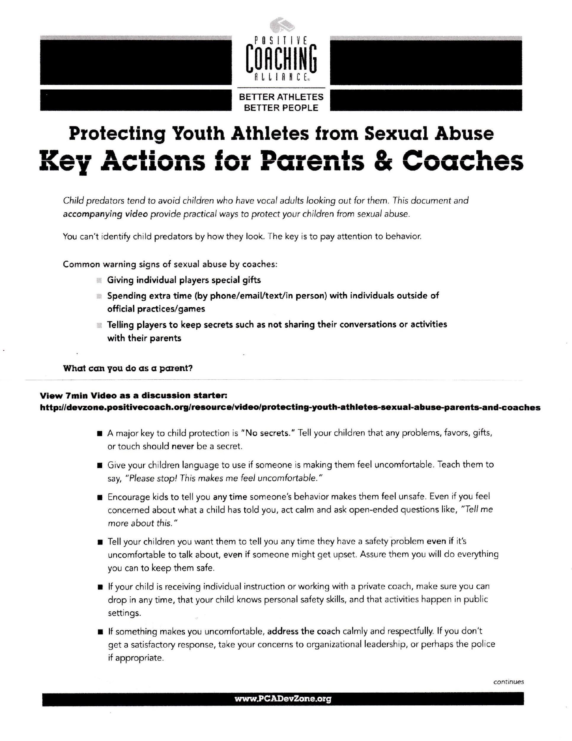
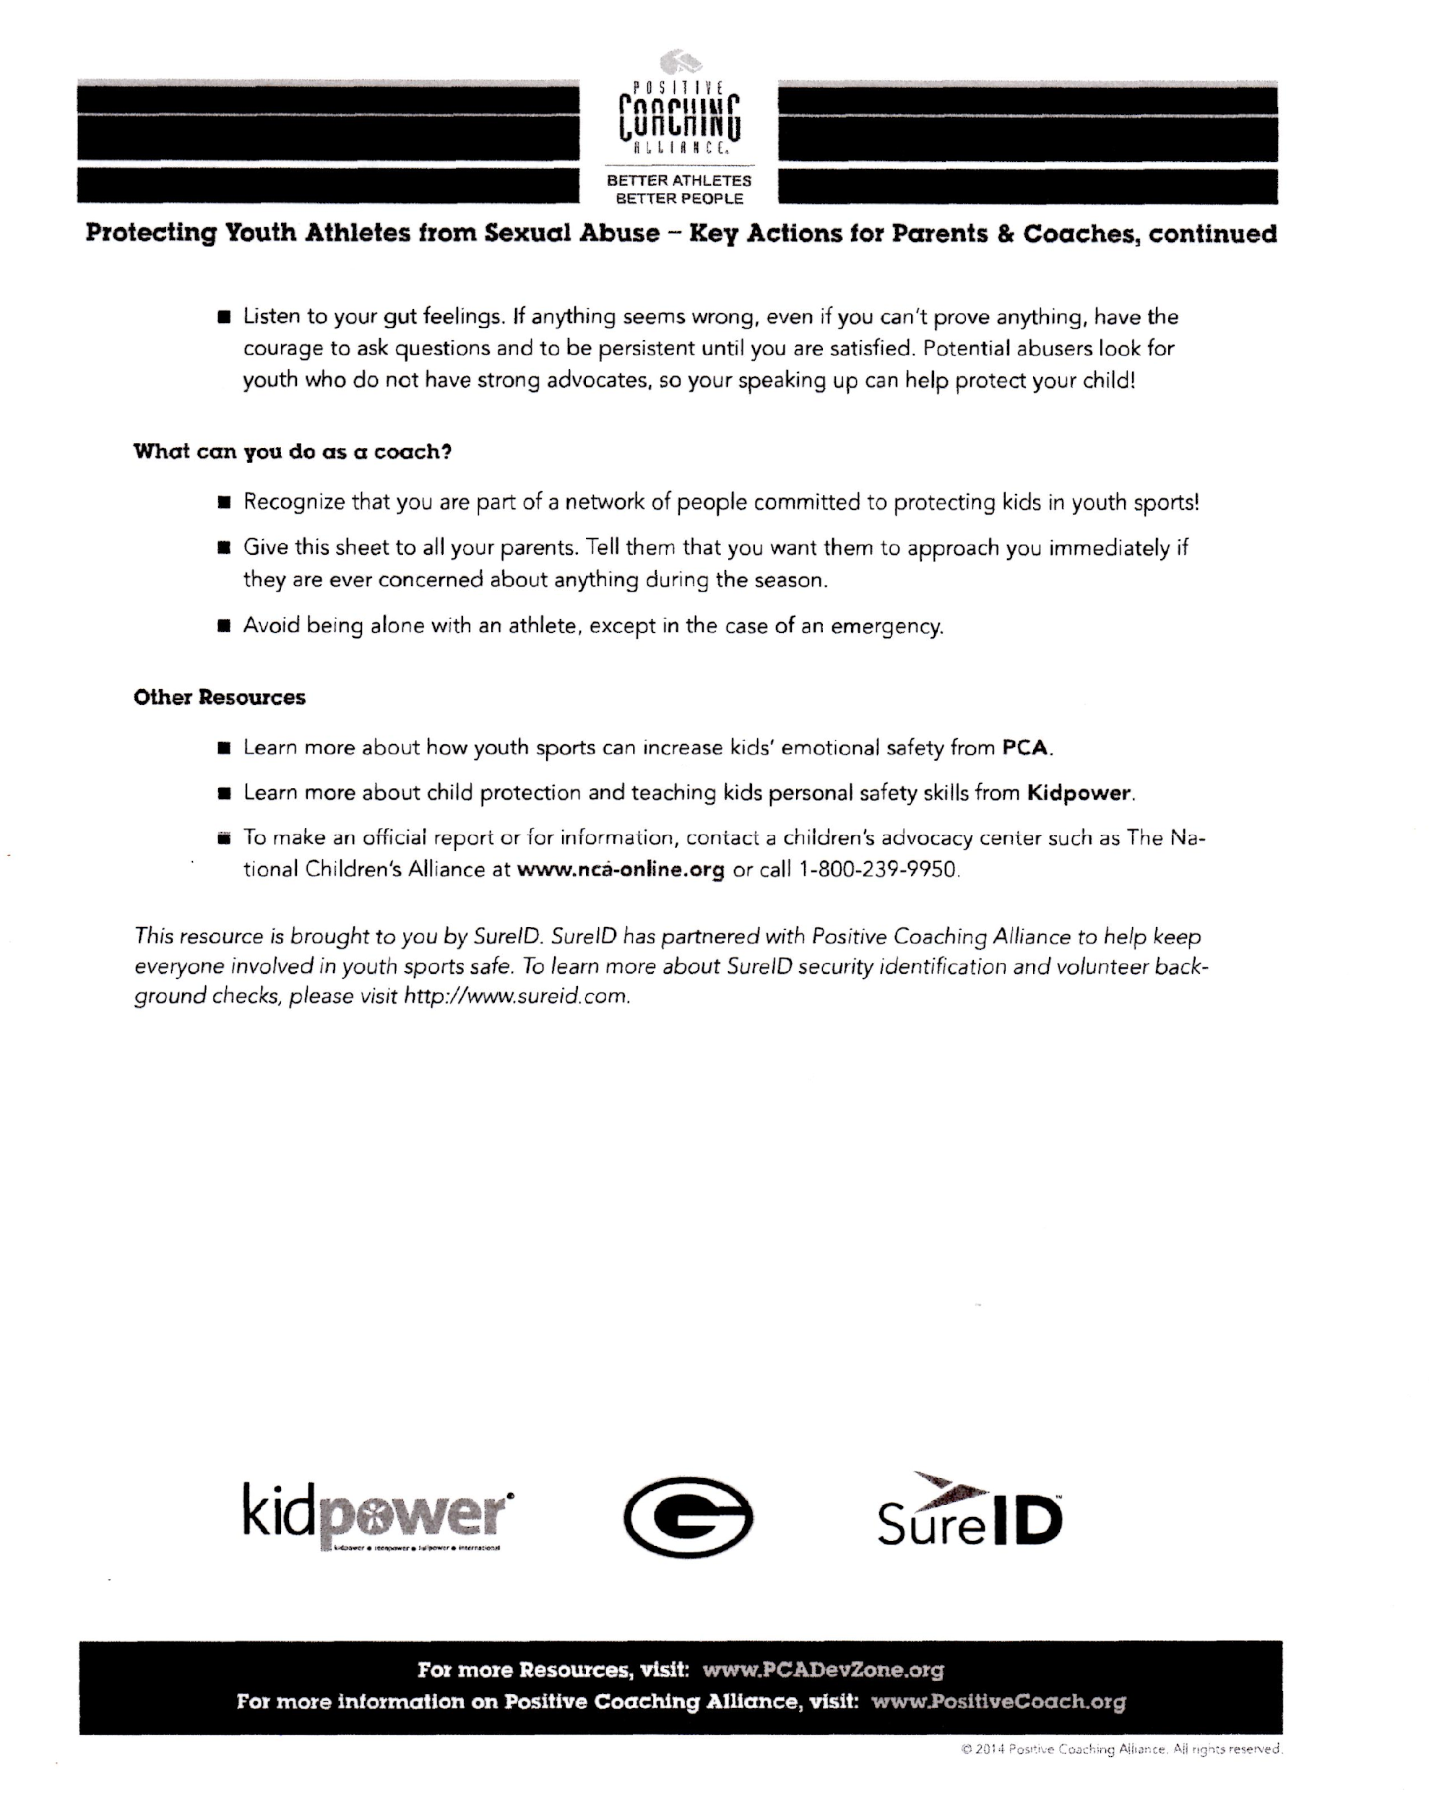



YCCHAL General Release Of Liability Form
In consideration of my child/ward (Minor’s Name) being allowed to participate in any way in the
Yellowstone County Home School Athletic League’s (YCCHAL) related events and activities, I, the undersigned, acknowledge, appreciate, and agree that:
- The risk of injury to my child/ward from the activities involved in these programs is significant, including the potential for permanent disability and death, and while particular rules, equipment, and personal discipline may reduce this risk, the risk of serious injury does exist;
- I, for myself, spouse, and child/ward, knowingly and freely assume all such risks, both known and unknown, even if arising from the negligence of the releases or others, and assume full responsibility for my child/ward’s participation;
- I willingly agree to comply with YCCHAL’s stated and customary terms and conditions for participation. If I observe any unusual significant concern in my child/ward’s readiness for participation and/or in the program itself, I will remove my child/ward from the participation and bring such attention of the nearest official immediately;
- I, for myself, my spouse, my child/ward, and on behalf of my/our heirs, assigns, personal representatives and next of kin, hereby release and hold harmless YCCHAL including its directors, officers, officials, agents, employees, volunteers, and other participants, sponsoring agencies, sponsors, advertisers, and owners and lessors of premises used to conduct the event (“Releases”), with respect to any and all injury, disability, death, or loss or damage to person or property incident to my child/ ward’s involvement or participation in these programs, whether arising from the negligence of the releases or otherwise, to the fullest extent permitted by law;
- I for myself, my spouse, my child/ward, and on behalf of my/our heirs, assigns, personal representatives and next of kin, hereby indemnify and hold harmless all the above Releases from any and all liabilities incident to my child’s/ward’s involvement or participation in these programs, even if arising from their negligence, to the fullest extent permitted by law.
I have read this release of liability and assumption of risk agreement, fully understand its terms, understand that I have given up substantial rights by signing it, and sign it freely and voluntarily without any inducement.

YCCHAL Emergency Medical Treatment Release
In the event that (Athlete’s Name) should require emergency
medical treatment while participating in a Yellowstone County Christian Homeschool Athletic League (YCCHAL) program under the immediate supervision of its designee(s), I authorize such designee(s) to approve professional medical services they deem necessary.
Parent/Guardian Signature Parent/Guardian Signature Date Signed

YCCHAL Parent & Athlete Agreement:
I have read, understand, and agree to abide by, the following:
- Rules of Conduct and Participation of the YCCHAL
- Parental Code of Conduct of the YCCHAL
- Constitution and By-Laws of the YCCHAL
- I have read the Parent/Athlete Concussion Information Sheet.
- I have read, and agree to follow, the conflict resolution of the YCCHAL.
I also acknowledge their use as the instrument of operation of YCCHAL. I understand that my adherence to the above Rules of Conduct is a condition of continued participation in the League. Violation(s) of the same can result in disciplinary actions by the coach and/or the Executive Council up to, and including, suspension or expulsion from the League. Furthermore, I agree that I am personally responsible for my child’s uniform and any equipment assigned to him/ her during the course of the season. I agree to properly care for them and return them at the appropriate time. I understand a replacement check ($150.00 for high school players and $80.00 for 5th - 8th grades) will be collected at the time the uniform is issued and then returned when the uniform is returned.
Parental/Guardian Signature Parental/Guardian Signature Date Signed

Athlete (Print):________________ Athlete Signature:______________ Team(s): ______________________
Season(s):_____________________
*Fees 2019/2020
- High School $400
- Jr High and Elementary $200

High School Academic Eligibility Form
In recognition of the standards set forth by Yellowstone County Christian Homeschool Athletic League
(YCCHAL), and by the Montana Christian Athletic Association (MCAA), I am making application to the YCCHAL Governing Board disclosing my academic enrollment for the stated academic season to insure my eligibility as an athlete for YCCHAL by attesting to one of the three (3) options set forth below. Furthermore, I understand that once I declare a high school grade level, I am limited to a maximum of four (4) years of participation, and can not declare a repeat of a grade. *Unless I graduate, take my G.E.D., or turn 19-years-old, all of which eliminate me from eligibility to participate in YCCHAL sports.
STUDENT NAME: GRADE LEVEL: ________________
ACADEMIC SEASON (Specify Fall or Winter) __________________________
ACADEMIC SCHOOL YEAR: _______________________________________
TEAM SPORT (Specify Basketball, Soccer or Volleyball): _________________________
Please select ONE of the three options listed below (and on the next page) that best describes your home school situation:
________ Option 1: I am NOT dually enrolled in any other institution and am a full-time homeschool student.
(This classification includes those students attending homeschool co-operatives)
________ Option 2: I am a homeschool student dually enrolled in an alternative institution and will be taking classes at the listed alternative school/academy. (This classification includes public schools, private schools, colleges, and MDA.)
ALTERNATIVE ORGANIZATION: ____________________________________
NUMBER OF COURSES ENROLLED IN AT ALTERNATIVE SITE: _________________________
* NOTE: As of 2013, eligibility for high school sports at a public school is determined by full-time attendance. Full-time attendance is defined as four classes. If a student is also enrolled at Montana Digital Academy (MDA), full-time is defined as two courses at school site and 2 courses through MDA. (2 Hour Career Center Block Classes count as two courses at school site). If you are a full-time student under these definitions, you are ineligible to play for YCCHAL.
________ Option 3: I am a full-time student at the following school and am making application to the YCCHAL Governing Board requesting permission to play for YCCHAL and attesting that my school does not have a team for the sport I am making application to play.
FULL TIME SCHOOL ATTENDANCE AT: ______________________________________________
*NOTE: MCAA allows students to play 5 years at the High School level, this includes JV, beginning in the 8th grade. This eligibility begins the first year the athlete begins to play. As a 7th grader, the MCAA allows students a total of 6 years at the High School level, upon YCCHAL & MCAA Board approval, and under the guidelines listed in the by-laws and constitution. Both 7th and 8th grade athletes are asked to play up, only if numbers are low and the High School level is in need of players to complete the team. If an athlete plays on either JV or Varsity at the 7th or 8th grade level, this will begin his/her years of High School eligibility. A player will not be given any extra years of eligibility for being held back a grade level. If this is unclear, please speak with the athletic director for clarity.
By signing this form, I acknowledge that I have provided in this application a complete accounting of my academic status for the stated school year and season, and understand MCAA Eligibility.
STUDENT SIGNATURE: ___________________________________________ DATE: ______________________
PARENT SIGNATURE: _____________________________________________ DATE: ______________________


YCCHAL Parental Consent Form for Use of Athlete Images

(child name) _________________________________________________________________________
(child name) _________________________________________________________________________
(child name) _________________________________________________________________________
I / we, ________________________________ (print), the parent(s)/guardian(s) of the child(ren) named above hereby give Yellowstone County Christian Homeschool Athletic League (YCCHAL), in Billings, Montana, permission to:
- Photograph and videotape my child(ren) named above while engaged in YCCHAL sporting events and related activities; and
- Use the name and/or any size still or moving image/likeness depicting my child(ren) named above, including photographs, drawings, and audio/video footage, for the following uses:
Training, education, publicity, marketing, media, website, and publications, such as annual yearbook, newsletter, leaflet, brochure.
By signing below, I/we certify that I am/we are the parent(s) or legal guardian(s) of the child(ren) named above, that I/we have read this agreement, and that I/we fully understand the contents herein. This agreement represents my/our permanent consent to the
foregoing without further approval from me/us unless and until a written and signed revocation containing each signature below is received via certified mail by a duly elected officer or board member of YCCHAL.
Signature: __________________________________ Date: ______________
Signature: __________________________________ Date: ______________
*Please also indicate if you would allow your child to be filmed/photographed, but do NOT want their name listed in the newspaper or our website.


YCCHAL BOARD MEMBER CONTACT:
Board members are elected at the annual meeting in April/May & serve as volunteers for a one year term.
President: Scott Wetzel | president@ycchal.org
V. President: Dena Truchot | vicepresident@ycchal.org
Secretary: Celina Allen  Treasurer: Amy Schiffner | secretary@ycchal.org treasurer@ycchal.org
Member at Large: Jessica Wenning  Appointed by the YCCHAL Board to serve one year~ | memberatlarge@ycchal.org
Athletic Director (AD) J.Wiesner, S.Roach, D.Truchot | ad@ycchal.org
This parent handbook and other helpful documents may be found at ycchal.org in the Documents tab.
Thank-you League Families for your service & participation...for future Knights to come!

